STUDENT TABLE ,WITH INSERTED DATA:

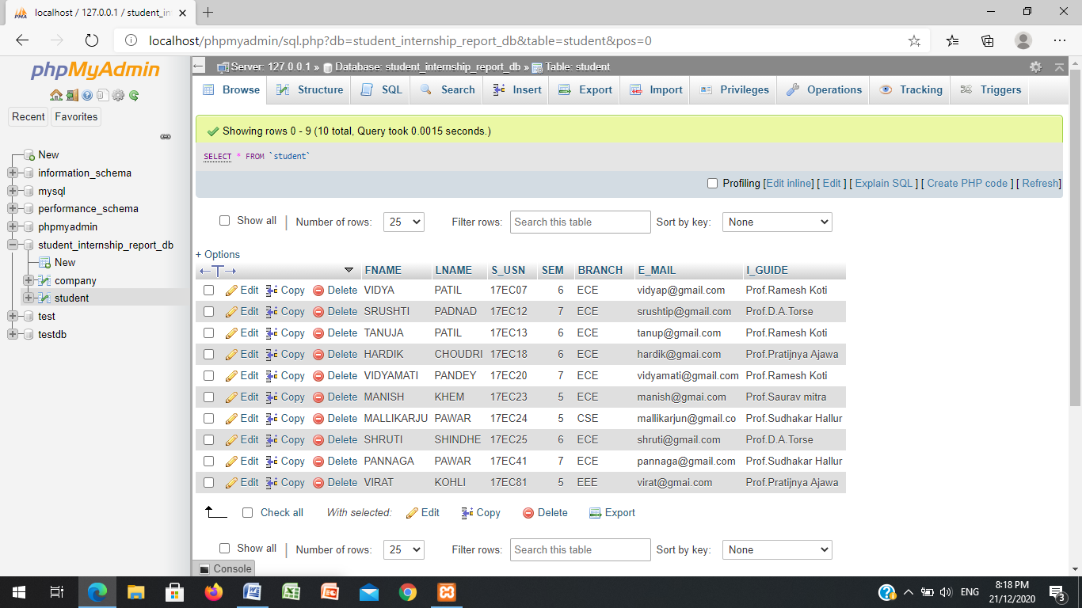

COMPANY TABLE, WITH INSERTED DATA:

